Sorted search: Brute Force

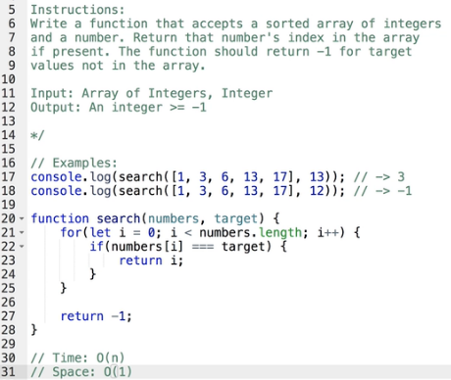

Program: Balanced Brackets

console.log(isBalanced('(1+2)\*{(55+66)}'))

function isBalanced(str){

const open = '({[';

const closed = ')}]';

const openStack = [];

const matches = {

')':'(',

'}':'{',

']':'['

}

for(let i=0; i<=str.length; i++){

const char = str[i];

if(open.includes(char)){

openStack.push(char);

}

if(closed.includes(char)){

const lastOpenBaracket = openStack.pop();

if(matches[char] !== lastOpenBaracket )

return false;

}

}

return !openStack.length;

}

//Time: O(n) //because the loop is running (str.length) n number of times

//Space: O(n) // in openStack array we are storing items roughly proportional to

//str.length